TWINNING PROJECT
SR13/IB/EN/03
“Further development of chemicals and biocides products management in the Republic of Serbia”

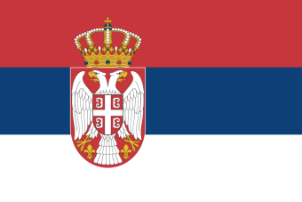 |  | 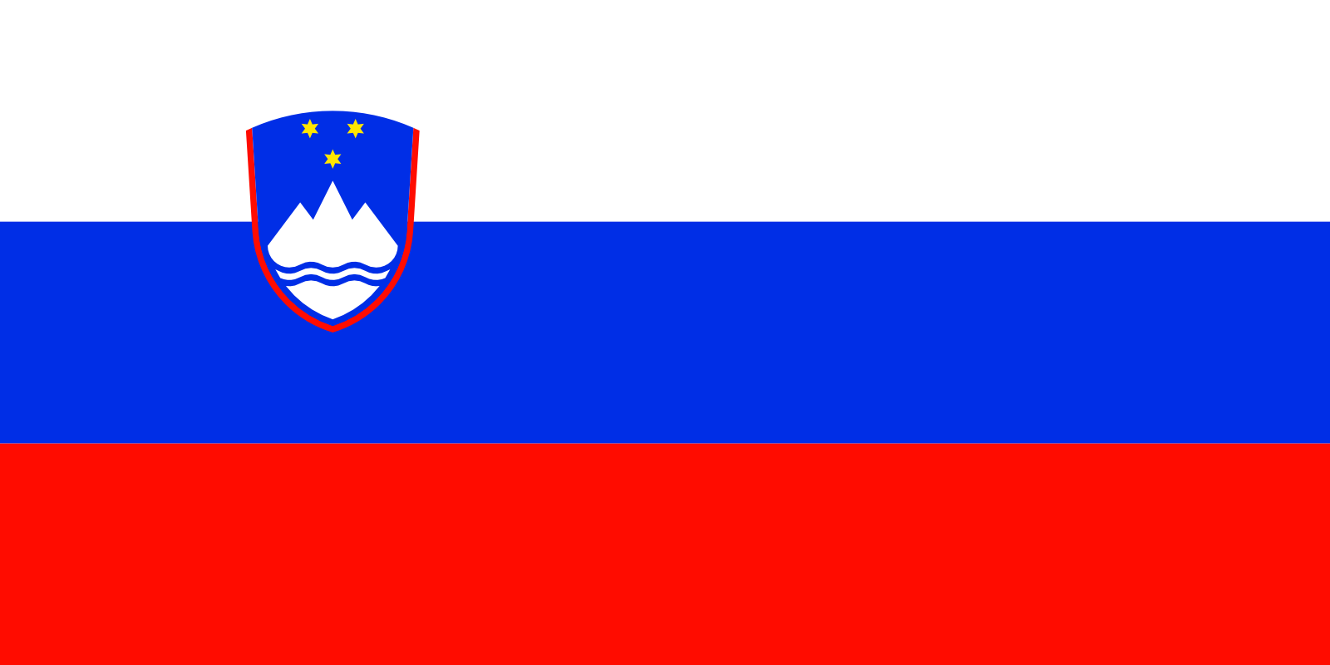
Financed by the European Union – Instrument for Pre Accession Assistance (IPA)

Job Vacancy Announcement for:
“Resident Twinning Adviser” (RTA) Assistant

Post reference number: | RTA/A/A1
Place of work: | Ministry of Agriculture and Environmental Protection (MAEP), Belgrade, Serbia
Estimate starting date: | October 2015
Period of employment: | 24 months (full time)
Closing date for applications: | 30 of September 2015 (24:00 Belgrade time, GMT+1)

BACKGROUND
Within the Republic of Serbia Ministry of Agriculture and Environmental Protection (MAEP) as Competent Authority, Department for Chemicals is responsible for harmonisation of Serbian legislation with the EU acquis on chemicals and biocidal products, thus for chemicals management.
Chemicals management is regulated by the Law on Chemicals and the Law on Biocidal Products that have been harmonized with relevant provisions of the EU legislation to the reasonable extent. National legislation shall be updated accordingly to the amendments of the relevant EU legislation (REACH, CLP, BPR). In order to facilitate implementation of legislation, but also to build capacity for performing of all the CA’s tasks under the relevant EU legislation after the accession, central staff for chemicals management needs to upgrade professional capacities, especially with regard to obligations which relate to procedures that are not incorporated into the national legislation.
Overall objective of this Twinning Project is to assist Serbia to meet environmental, health and climate Acquis through administrative capacity building. The project aims to support the Department for Chemicals to develop new legislation on biocidal products aligned with BPR, to enhance knowledge and skills necessary for chemicals and biocidal products management as well as for participation in the work of ECHA and EC bodies.

DUTIES
RTA Assistant should provide: administrative assistance to the RTA during the whole duration of the Twinning Project and, support the effective delivery of the Twinning Contract mandatory results while ensuring a good communication flow. In addition,
he/she should provide administrative support on a daily basis to the Member States experts involved for short-term working missions to Belgrade within the Project’s framework.

In particular duties of the RTA Assistant comprise the following:
- assisting RTA in performing general project duties (general tasks of office management on a daily basis);
- Supporting preparation and delivery of working activities as foreseen in the Twinning Contract, including organization and logistic of training sessions, conferences, experts missions, etc. and related administrative tasks;
- translation and interpretation services on a daily basis (interpretation at meetings and during STEs missions, translation of certain documents e.g. reports and project outputs);
- preparation of logistics for the project events;
- Drafting and editing documents relevant to the project in Serbian and English;
- Taking minutes of meetings, preparing notes and summary records;
- Supporting in providing travel arrangements and arrange meetings for the RTA, Medium Term Experts, Short-Term Experts and other foreign specialists involved in the project as well for the BC experts;
- Supporting preparation of the required documentation for experts missions: Terms of Reference, Mission Certificates, Side Letters, record keeping and monthly travel for Project Leaders including the RTA Expenses and Implementation expenses;
- Supporting RTA in his liaison with Delegation of the European Union to Belgrade and Serbian Institutions at the national and local level;
- Other duties and ad hoc support to the RTA in the Beneficiary country, including advice and guidance on local issues.

QUALIFICATIONS AND EXPERIENCE REQUIRED
The ideal candidate will be hard working individual with excellent written and oral communication skills and the ability to work in the fast paced environment, closely with the RTA and team of experts.

To be eligible, an applicant must have:
- University degree or equivalent qualification in discipline relevant for the position;
- Capacity to maintain effective document and record management;
- Excellent communication and social skills;
- Strong multi-tasking skills;
- Fluency in both written and spoken Serbian and English languages;
- Full computer literacy;
- practical experience in project administration and management, preferably in
- other EU funded projects;
- Knowledge of EU chemicals policy and management would be considered as an advantage.

Besides the following attributes would be an asset:
- Experience as RTA Assistant in Twinning projects;
- Work experience in an international environment;
- Knowledge of and/or experience in the Serbian Public Administration.

CONDITIONS OF EMPLOYMENT
The assignment is full time; RTA Assistant contract will run from the date of the signature throughout the period of implementation of the Twinning Contract (approximately 24 months).
Successful applicant will be an independent consultant, on the basis of the standard IPA contracts for services. The RTA Assistant will be self-employed and will undertake full responsibility for the payment of all taxes and obligations deriving from the legislation in force, including for those related to medical and social insurance.

NOTE: Twinning Manual foresees that the chosen RTA assistant funded by the Twinning contract must not have had, at least during the 6 months preceding their recruitment, any contractual relation with the beneficiary administration.

APPLICATION AND SELECTION PROCEDURES
Qualified candidates are kindly asked to send their applications, duly completed in English, not later than 30 September 2015 (24:00 Belgrade time, GMT+1) to both of the following E-mail addresses: ipa.chemicals@eko.minpolj.gov.rs; gp-ursk.mz@gov.si with this specification on the subject: “SURNAME”_REF: RTA/A/1
Application shall include:
- Letter of intention explaining the compliance with the eligibility criteria for the specification post;
- CV* (Europass format);
- Copies of supporting documents shall be presented by the candidates invited on interview.

Only short-listed candidates will be notified and invited for the interview which will be held in Belgrade sometime at the beginning of October 2015.

NOTE: Incomplete applications or applications sent after the above mentioned deadline will be disqualified and treated as non-eligible.
*CV form in EU format is available at: http://europass.cedefop.europa.eu/en/documents/curriculum-vitae/templates-instructions

