Local publication for call for proposals
Support to local self-government units  Publication reference: EuropeAid/139223/ID/ACT/RS | 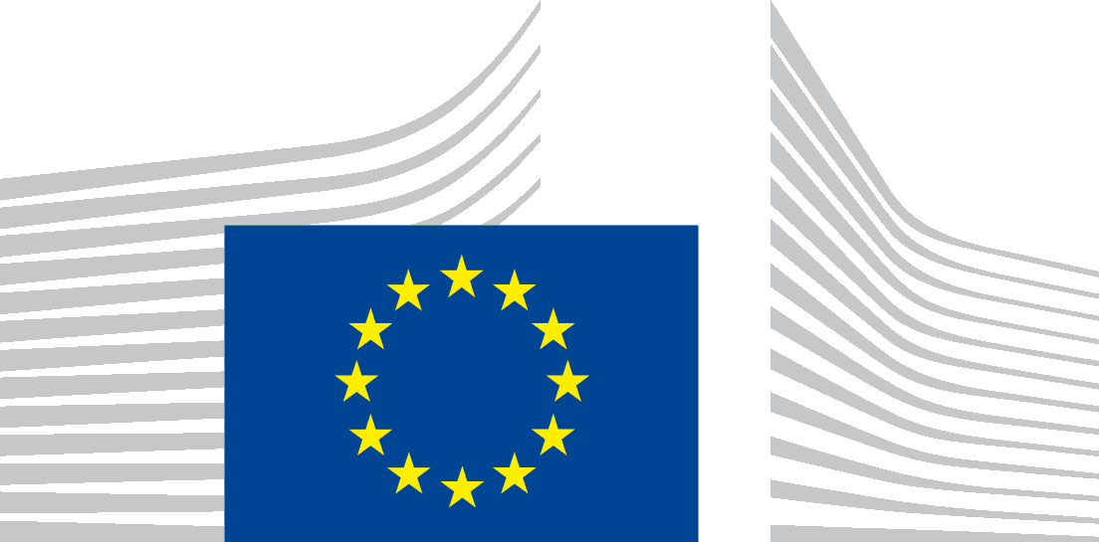
The Government of the Republic of Serbia, represented by the Ministry of Finance, Department for Contracting and Financing of EU Funded Programmes (CFCU) is seeking proposals for strengthening the capacities of the local self-government units within the Republic of Serbia for property management and provision of related services, thus bringing the public administration closer to citizens and business, with financial assistance from the National Action Programme for Serbia IPA 2014.

The full Guidelines for Applicants are available for free download on the following internet site:
- CFCU: www.cfcu.gov.rs
- EuropeAid:
https://webgate.ec.europa.eu/europeaid/online-services/index.cfm?do=publi.welcome

The deadline for submission of proposals is October 20, 2017. In case of hand deliveries, the deadline for receipt is at 15:00 local time on the same day.

The schedule of the information sessions will be published at a later date in the following websites:
- CFCU: www.cfcu.gov.rs
- EuropeAid:
https://webgate.ec.europa.eu/europeaid/online-services/index.cfm?do=publi.welcome

