Local publication for call for proposals
Development of innovative, integrated youth tailored services and active inclusion models  Publication reference: EuropeAid/159572/ID/ACT/RS | 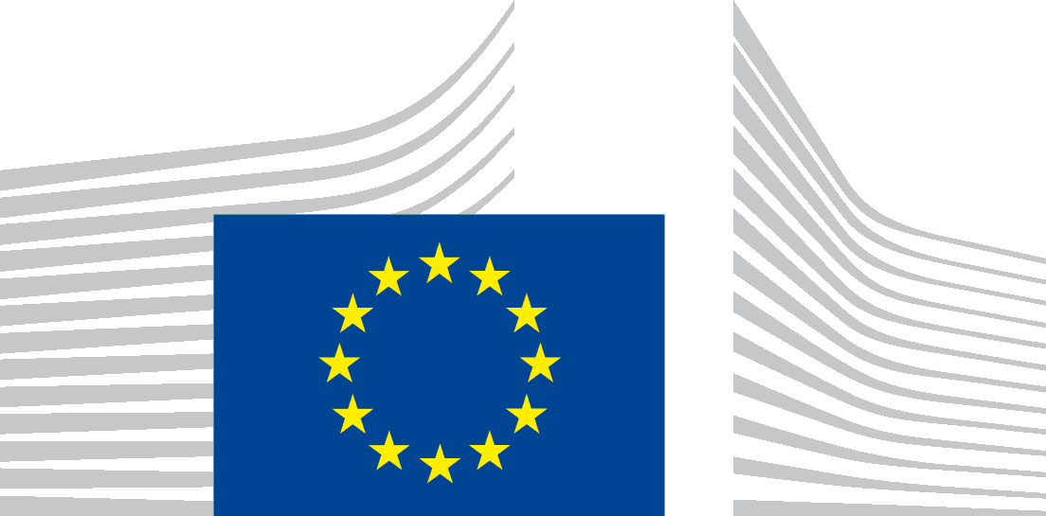
The Government of the Republic of Serbia, represented by the Ministry of Finance, Department for Contracting and Financing of EU Funded Programmes (CFCU) is seeking proposals to contribute to the implementation of employment and social reforms fostering a high-employment economy, namely through increase of youth employment and active inclusion measures, with financial assistance from the IPA 2014 National Programme.

The full Guidelines for Applicants are available for free download on the following internet sites:
- CFCU: www.cfcu.gov.rs
- EuropeAid:
https://webgate.ec.europa.eu/europeaid/online-services/index.cfm?do=publi.welcome

The deadline for submission of proposals is May 3rd, 2018. In case of hand deliveries, the deadline for receipt is at 15:00 local time on the same day.
The schedule for the information sessions will be published at a later date in the following websites:
- CFCU: www.cfcu.gov.rs
- EuropeAid:
https://webgate.ec.europa.eu/europeaid/online-services/index.cfm?do=publi.welcome

