Local publication for call for proposals
Cross-border Programme Serbia – North Macedonia 2016-2020 under the Instrument of Pre-accession Assistance (IPA II), allocations 2016 and 2017  Publication reference: EuropeAid/165171/ID/MULTI | 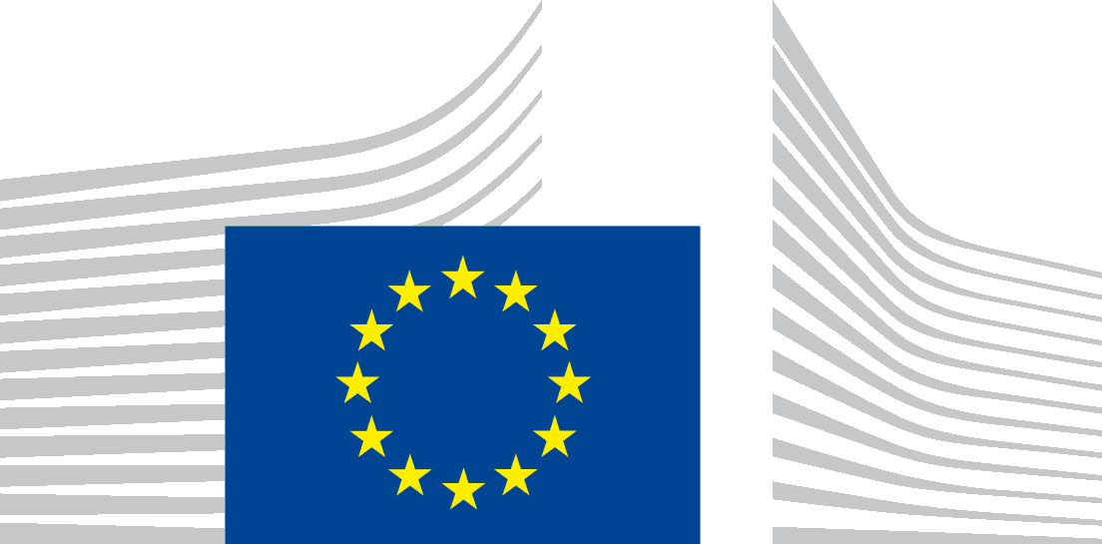
The Government of the Republic of Serbia, represented by the Ministry of Finance, Department for Contracting and Financing of EU Funded Programmes (CFCU) is seeking proposals to contribute to Cross-border Programme Serbia – North Macedonia 2016-2020, with financial assistance from the IPA 2016 and 2017.

The full Guidelines for Applicants are available for free download on the following internet sites:
- CFCU: www.cfcu.gov.rs
- EuropeAid:
https://webgate.ec.europa.eu/europeaid/online-services/index.cfm?do=publi.welcome

The deadline for submission of proposals is September 27, 2019. In case of hand deliveries, the deadline for receipt is at 15:00 local time on the same day.
Information session on this call for proposals will be held in the following cities: Leskovac, Vranje, Skoplje and Kumanovo.
The schedule for the information sessions will be published at a later date in the following websites:
- CFCU: www.cfcu.gov.rs
- EuropeAid:
https://webgate.ec.europa.eu/europeaid/online-services/index.cfm?do=publi.welcome

