Belgrade, 17/09/2020

CONTRACTING AUTHORITY’S CLARIFICATIONS No. 1
“Procurement of equipment for plant variety testing”
Publication ref.: EuropeAid/140433/IH/SUP/RS
No. | Question | Answer
1 | Zbog konkursa za posao ,imam pitanje u vezi sa izgradnjom rashladnih komora za čuvanje semena u PSS Sombor.  Panel od kamene vune se ne koristi u hlađenju i za izgradnju rashladnih komora. Koristi se poliuretanski panel PUR ili PIR  Da li u ponudu mogu da stavim poliuretanski sendvič panel PUR ili PIR ? Da li mogu da budu poliuretanska hladionička klizna vrata?  The question is related to the construction of cooling chambers for storing seeds in PSS Sombor.  The stone wool panel is not used in cooling and for the construction of cooling chambers. Polyurethane panel PUR or PIR is used.  Can a polyurethane sandwich panel PUR or PIR be offered? Can it be a polyurethane refrigerator sliding door?  - UNOFFICIAL TRANSLATION | Please note that in accordance with PRAG 2020 section 4.3.4 Additional information during the procedure, the Contracting Authority cannot give a prior opinion on the assessment of the tender.  Regarding the sliding door “each chamber should have a sliding cold storage panel doors..” as stated in Annex II + III: Technical Specification – Item 4.  Polyurethane sandwich panels can be also PUR or PIR, but they need to meet thermal characteristics of 60 mm thick panels with stone wool filling requested by TS.  Polyurethane refrigerator sliding door can be also PUR or PIR, but it needs to meet thermal characteristics of 60 mm thick panels with stone wool filling requested by in Annex II + III: Technical Specification – Item 4.
2 | Annex II+III: Technical Specification - Item 4: Cold storage chambers for storing seed samples:  Can you please provide a floor plan for the building in which storage chambers should be installed?  It is requested that each of storages is 5x8x4m in dimensions. Please clarify if you refer to internal or external dimension of the storage. Should storages be separated or connected, i.e. should they have one common dividing wall.  The floor material is not specified. Do you need floor covering for chambers? | Each of the five chambers has dimensions of 5x8x4m (external measures) and each chamber should be separate, but there is a common dividing wall between the chambers.  Floor coverings are not necessary because there is already a ferrocement base with thermal insulation.
3 | Annex II+III: Technical Specification - Item 4: Cold storage chambers for storing seed samples:  It is requested: Panels of the cold storage are wall panel T = 60mm with stone wool filling.  Is any special fire safety level requested for the chamber? This question refers to stone wool filling and its bad isolating characteristics. Is the stone wool filling obligatory or we can propose some other solution, like PIR? | Panels can be also PUR or PIR, but they need to meet thermal characteristics of 60 mm thick panels with stone wool filling requested by Annex II+III: Technical Specification – Item 4.  Special fire safety level is not requested.
4 | Annex II+III: Technical Specification - Item 4: Cold storage chambers for storing seed samples: It is requested: Each chamber should have a sliding cold storage panel doors with stone wool filling t = 60mm with stainless steel sheet bordering and stainless steel frame for sliding doors.  Please clarify if any special fire safety level requested for doors.  Is the stone wool filling obligatory or we can propose some other solution, like PIR?  Please clarify why is stainless steel frame for sliding doors requested, while in the definition of the chamber it is requested that panels should be galvanised and plasticised steel sheet. | Sliding doors for each of the five chambers can be with PIR or PUR filling provided they meet thermal characteristics of 60 mm thick panels with stone wool filling requested by Annex II+III: Technical Specification – Item 4.  Special fire safety level is not requested for the doors.  As for the door frame question, the answer is due to the durability of the door itself.
5 | Annex II+III: Technical Specification - Item 4: Cold storage chambers for storing seed samples: It is requested: The cooling system should be a common combined cooling unit for all 5 chambers.  Is the position of the cooling system fixed? In that case, what is the distance between the cooling system and the first chamber?  Which refrigerant fluid should be provided?  R404A, R449A or something else? | The position of the cooling system is fixed and the longest distance between the cooling unit and the first chamber should not exceed 12m.  Refrigerant fluid should be provided in accordance to the usual environmental standards, market standards and national regulations of Republic of Serbia.
6 | Annex II+III: Technical Specification - Item 4: Cold storage chambers for storing seed samples: It is requested: One chamber should be equipped with mobile shelving for seed storage. This chamber should have 5 mobile shelving each 6m long and 2m high, with shelf distance 0.5m and shelf width 0.7m. Mobile shelving should be mechanically driven.  Please provide more detailed specification for this mobile shelving:  What material should be used for shelving?  It is not clear how each shelving should look like. How many horizontal shelves per each rack do you need? Can you provide a drawing with design of one mobile shelving and position of all 5 mobile shelving?  Please specify what kind of mechanical drive is requested for shelving? | As for the mobile archive shelves, they should be made of metalprotected from corrosion and mechanically driven with manual movement without assistance of equipment e.g. manual fork-lifter.  Four shelves per each rack are needed.  Attached is an outline of movable shelves for one chamber.
7 | Annex II+III: Technical Specification - Item 5 Portable computers for on-site data processing:  Specification for Portable computer is to detailed and it indicates an obsolete model with some outdated specification (like optical drive, VGA connector and 6 cells battery in max. 2.2Kg weight laptop).  Therefore, we could not find fully compliant laptop with EU origin on the market.  In order to provide a proper offer, we propose to amend the following specification:  - Requested: Optical drive: minimum DVD Super Multi (reader/writer)  Amended: Optical drive: minimum DVD Super Multi (reader/writer), internal or external USB  - Requested: Connectors: minimum 1xVGA  Amended: Connectors: minimum 1xVGA (internal or external adapter)  - Requested: Battery and adapter: minimum 6 cells 48Wh, power adapter minimum 65W  Amended: Battery and adapter: minimum 3 cells, power adapter. | Models requested by the Annex II+III: Technical Specification – Item 5 are available according to the market research.  Please note that the Annex II+III: Technical Specification – Item 5 will remain unchanged. As specified in the Annex II+III: Technical Specifications – Item 5, some requirements are required as minimum.
8 | Annex II+III: Technical Specification - Two row harvester for harvesting microtrials:  It is requested:  Engine (Euro Diesel) 50-80 KW;  Engine 3000-4000 ccm³  Please note that these two specifications are contradictory in the era of engine downsizing. It is a practice of utilizing smaller combustion engines over larger ones of the same power capacity when manufacturing vehicles. It is the result of engine manufacturers attempting to provide more efficient vehicles that emit fewer emissions, often mandated by legislative standards.  Therefore, we propose to exclude the requested specification: Engine 3000-4000 ccm³.  The other requested specification: Engine (Euro Diesel) 50-80 KW, is sufficient to define engine performance. | According to the needs of performing microtrials, harvester with a given engine cc3 capacity is needed.  Please note that Annex II + III: Technical Specification – Item 1 will remain unchanged.
9 | Reference is made the project in subject.  We are hereby to request some clarifications regarding line item no. 2:  - Please clarify the meaning of “seed divider for a single row and seed divider for two rows”  - Please clarify the working width of the planter  - Do you need also the manure spreader for this item?  - Please clarify if you need disc or share type | • The seeder should have the possibility to sow different seeds in each of the four rows (single-row plots). The two-row plot option is most often used, which represents the possibility of sowing one type of seed in the first two rows and another type of seed in the second two rows. Of course, the option to sow the same seed in all four rows (four rows plot) is needed.  • The working width of the seeder is 4x0.75 m, and in the transport position the maximum width is 2.55 m.  • Manure spreaders are not required  • Both discs and shares are needed.  All parts listed in Annex II+III: Technical specifications are required and not optional.
10 | Regarding line item no. 1, please note that the machine specified in tender is out of production/obsolete since many years. Moreover, the machines available on the market cannot be used with tractors but need to be attached to harvesters.  We request you to please revise the specifications to permit all bidders to propose current models. | Models requested by the Annex II+III: Technical specifications – Item 1 are available according to the market research.  Item 1 is self-powered (it uses its own drive). In the Annex II+III: Technical specifications – Item 1 it is stated that this engine has a power of 5o to 80 KW and a 3000-4000 ccm.  Please note that the Annex II+III: Technical specifications – Item 1 will remain unchanged.
11 | I have looked on the TED site but cant seem to access the tender details.  Would you be so kind as to send me either a link to the details or a PDF of the tender itself. | Please see the following link on CFCU website: http://www.cfcu.gov.rs/tender.php?id=594  https://webgate.ec.europa.eu/europeaid/online-services/index.cfm?ADSSChck=1571777820243&do=publi.welcome&aofr=140433&nbPubliList=15&orderbyad=Desc&orderby=upd&searchtype=RS&userlanguage=en

Annexes:

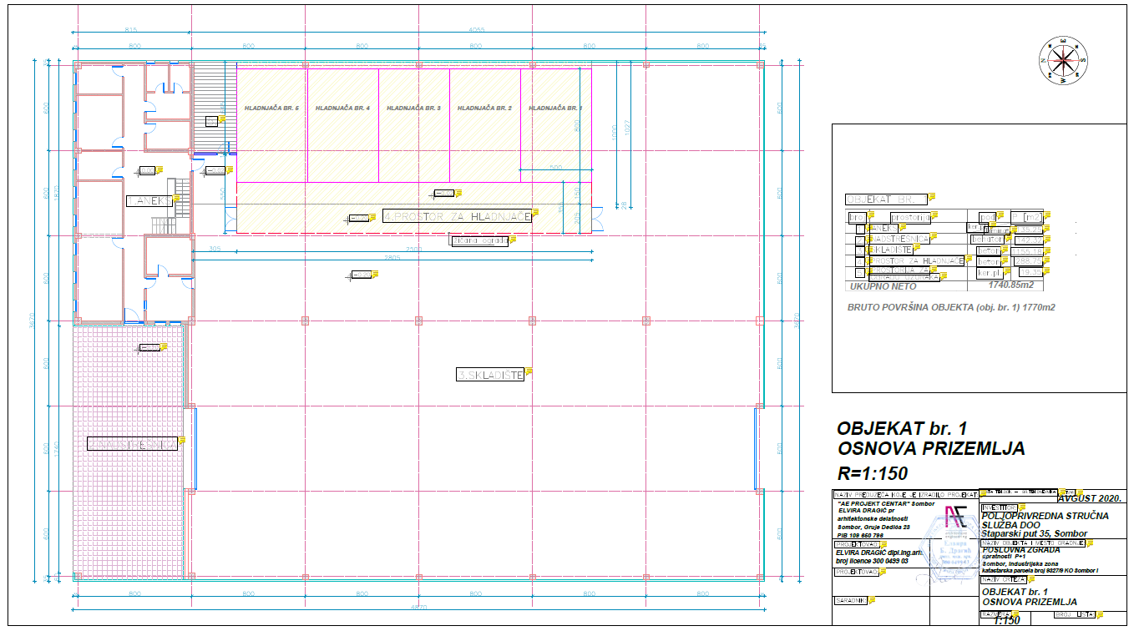

Sketch accompanying answer number 2

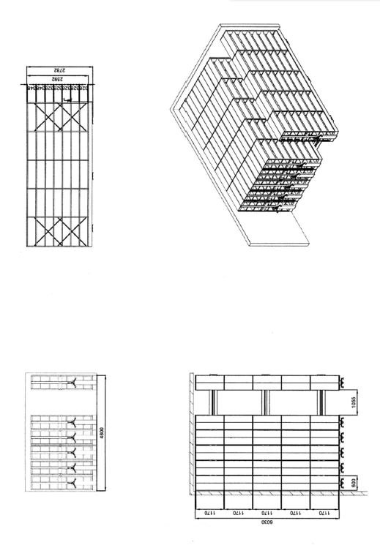
Sketch accompanying answer number 6.

Pictures shown is for illustration purpose only. Actual products may vary, as long as in the line with the respective specifications.

