Local publication for call for proposals
Cross-border Programme Serbia – Montenegro 2014-2020 under the Instrument of Pre-accession Assistance (IPA II), allocations 2016, 2017 and 2018  Publication reference: EuropeAid/165238/IH/ACT/Multi | 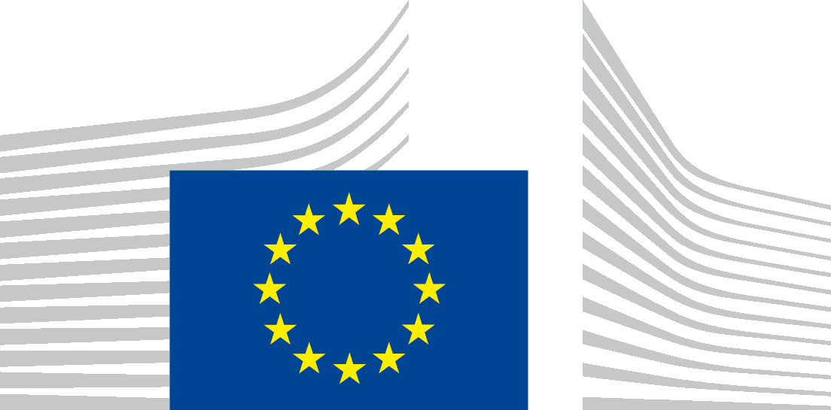
The Government of the Republic of Serbia, represented by the Ministry of Finance, Department for Contracting and Financing of EU Funded Programmes (CFCU) is seeking proposals to contribute to Cross-border Programme Serbia – Montenegro 2014-2020, with financial assistance from the IPA 2016, 2017 and 2018.

The full Guidelines for Applicants are available for free download on the following internet sites:
- CFCU: www.cfcu.gov.rs
- EuropeAid:
https://webgate.ec.europa.eu/europeaid/online-services/index.cfm?do=publi.welcome

The deadline for submission of proposals is December 27th, 2019. In case of hand deliveries, the deadline for receipt is at 15:00 on the same day.
Information session on this call for proposals will be held in the following cities: XXX.
The schedule for the information sessions will be published at a later date in the following websites:
- CFCU: www.cfcu.gov.rs
- EuropeAid:
https://webgate.ec.europa.eu/europeaid/online-services/index.cfm?do=publi.welcome

