Local publication for call for proposals
Cross-border Programme Serbia- Bosnia and Herzegovina 2014- 2020 under the Instrument for Pre-accession Assistance (IPA II), allocations for 2016, 2017 and 2018*  Publication reference: EuropeAid/165834/ID/MULTI | 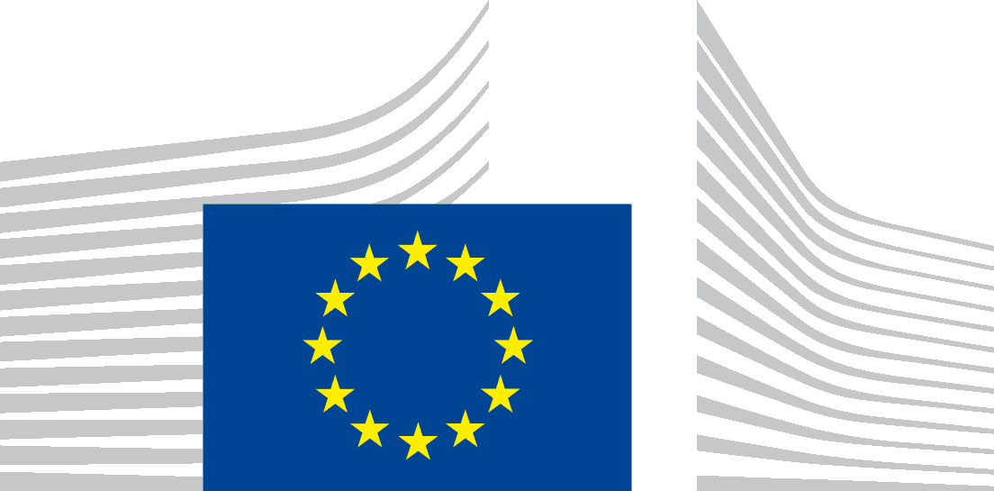
The Government of the Republic of Serbia, represented by the Ministry of Finance, Department for Contracting and Financing of EU Funded Programmes (CFCU) is seeking proposals to contribute to Cross-border Programme Serbia – Bosnia and Herzegovina 2014-2020, with financial assistance from the IPA 2016, 2017 and 2018.

The full Guidelines for Applicants are available for free download on the following internet sites:
- CFCU: www.cfcu.gov.rs
- EuropeAid:
https://webgate.ec.europa.eu/europeaid/online-services/index.cfm?do=publi.welcome

The deadline for submission of proposals is February 21st, 2020. In case of hand deliveries, the deadline for receipt is at 15:00 on the same day.
Information session on this call for proposals will be held in the following cities: Zlatibor, Vrdnik, Bijeljina and Kiseljak.
The schedule for the information sessions will be published at a later date in the following websites:
- CFCU: www.cfcu.gov.rs
- EuropeAid:
https://webgate.ec.europa.eu/europeaid/online-services/index.cfm?do=publi.welcome

Leftover from allocation for 2016 from the 1st CfP

